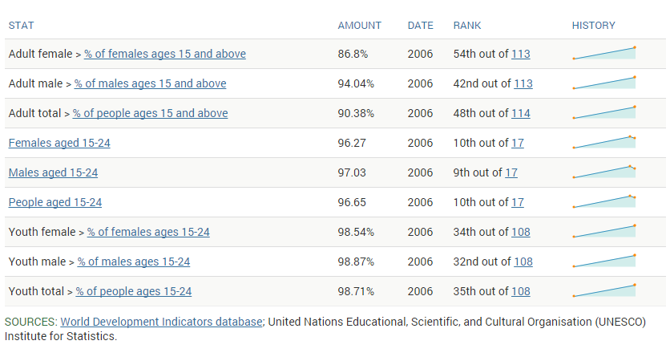
Indonesia’s educational system has seen a steady increase in quality over the last few years. Citizens between the ages of 15 and 24 have a literacy rate of 99.5%, while the overall adult population (age 15+) has a rate of 92.8%. These standards lean to favor the males on average. Despite these improvements, Indonesia still falls below the in many of the education expectations, and the country does not spend much on improving the education system. In spite of the obvious lack in quality the Indonesian education has, the country only spends 3% of its GDP on improving this. The country faces many difficulties in educating its citizens, not least of which is the shear size of the country’s population.

The chart above shows Indonesia’s literacy rates for the year of 2006, as well as the ranking of the country in the world. On the far right we can see that the system despite not being the best, has made many strides towards improving. The gender inequality shown in this chart has reduced greatly in recent years. College enrollment has also grown steadily. Although the country’s rank has not improved as much. Indonesia is among the lowest ranked in the science, math, and reading.
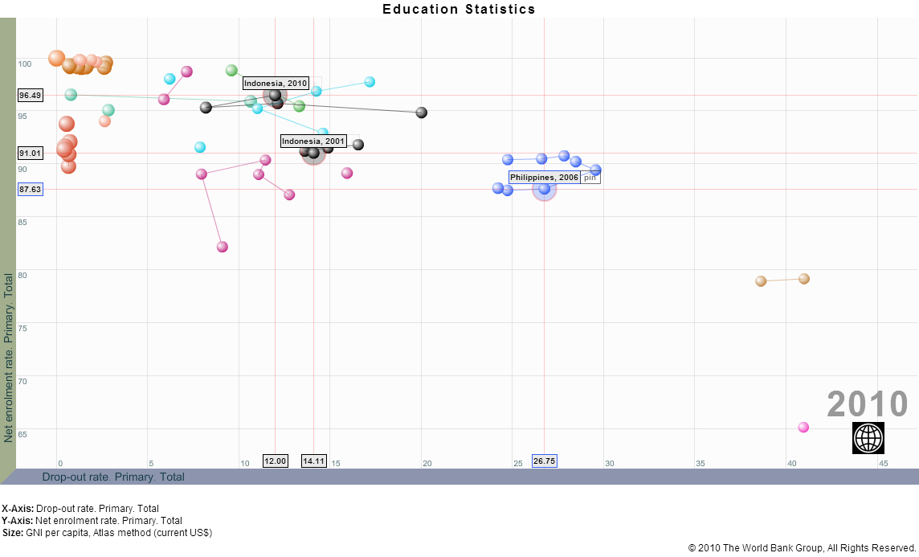
This is likely due to the country not putting enough investment into its future by way of improving its schools. Already the consequences of this are being seen, as the country is severely lacking a qualified local workforce for scientific and engineering positions. There are not many citizens graduating with math and science related degrees, placing the country at a disadvantage.
This graph show ten years of primary school enrollment and dropout data for a handful of Asian countries, provided by the World Bank Group. Indonesia is shown on this graph in black. As you can see, the dropout has risen and the enrollment rate has dropped. The country has made a disappointing step back in primary school enrollment. The country will have to invest more into its education system, if it ever hope to meets international standards.

Citations:
Indonesia Education Primary education Stats: NationMaster.com. (n.d.). Retrieved November 6, 2015.

Clark, N. (2014, April 4). Education in Indonesia - WENR. Retrieved November 6, 2015.

Data Visualizer. (n.d.). Retrieved November 6, 2015.

Statistics. (n.d.). Retrieved November 6, 2015, from http://www.unicef.org/infobycountry/indonesia_statistics.html

